**CASE STUDY - CONTAINERIZATION USING DOCKER I**

**Problem Statement:**

You work as a Devops Engineer in a leading Software Company. You have been asked to

Dockerize the applications on the production server. The company uses custom software,

therefore there is no pre-built container which can be used.

Assume the following things:

1. Assume the software to be installed is apache

2. Use an Ubuntu container

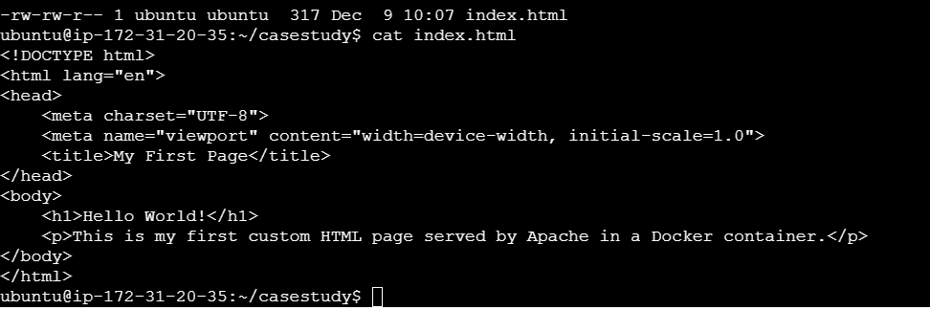

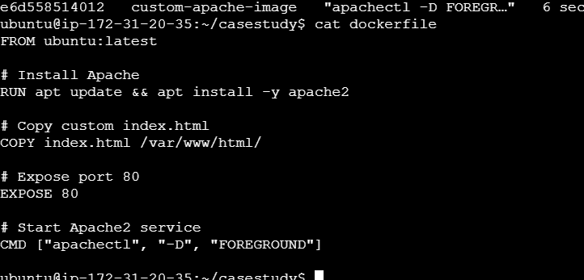

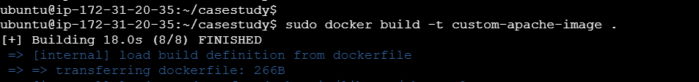



The company wants the following things:

1. Push a container to DockerHub with the above config

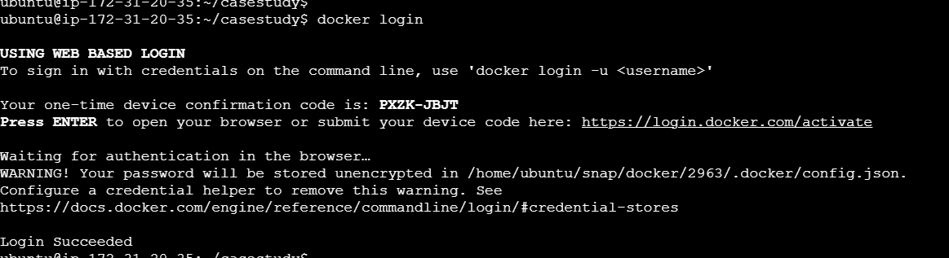

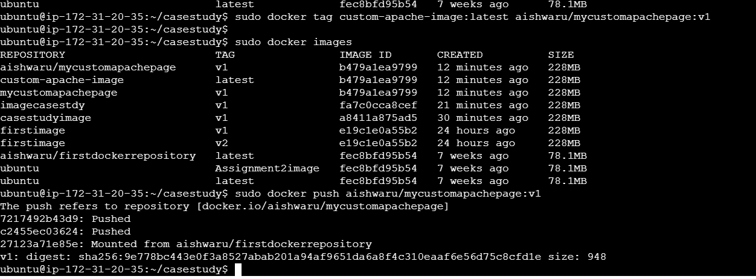

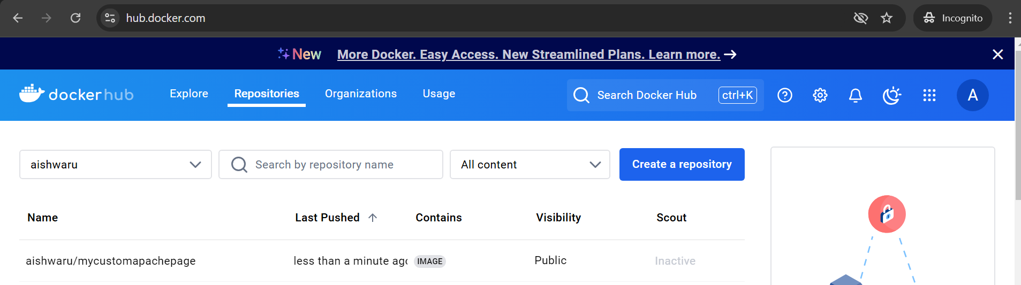

2. The Developers will not be working with Docker, hence from their side you will just get the

code. Write a Dockerfile which could put the code in the custom image that you have built





